CURWEN HAND SIGNS
John Curwen (1816-1880), a British Minister and scholar of music, invented tonic sol-fa in the middle of the 19th century, and as part of his system he developed a number of hand signs that represented the seven notes. The idea was that the hand signals would help pupils learn sight singing by acting as visual aids. Later in the century, Zoltán Kodaly (1882-1967) adopted Curwen’s hand signs in his system and amended them with a new set of his own gestures. Kodaly changed the orientation of the hand signs so that notes that were flat would point downwards and notes that were sharp would point upwards. Even though they didn’t know about the different types of learners, Curwen and Kodaly created a solid method for teaching the notes and solfege (tonic sol-fa) to children that caters to visual, auditory, read-write, and kinesthetic learners alike.

The proper way to teach Curwen hand signs / Kodaly hand signs is to start by signaling Do at waist level. Then as you go up the scale, move your hand upwards, so that by the time you’re at Ti, your hand is at eye level.
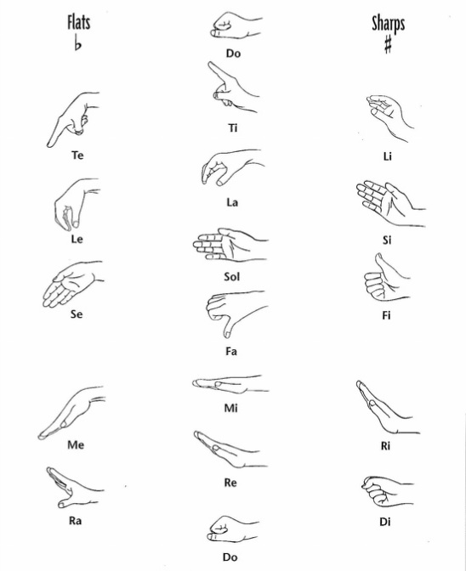
RHYTHM SYLLABLES
